**Backend Position Table:**

Position table is to manage the positions for each employee.

The picture below is the view of the position table which is you can create, update and delete the item you will create. It shows the reference table 1.1

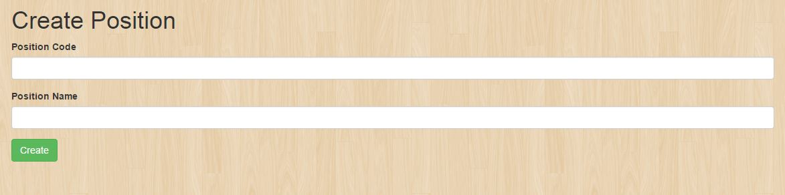

To create a Position just simply clicks this button:



It will display these fields:



**Backend Item table:**

The picture below is to view the Item table which is you can create, update and delete the item you will create. It show the reference table 1.1

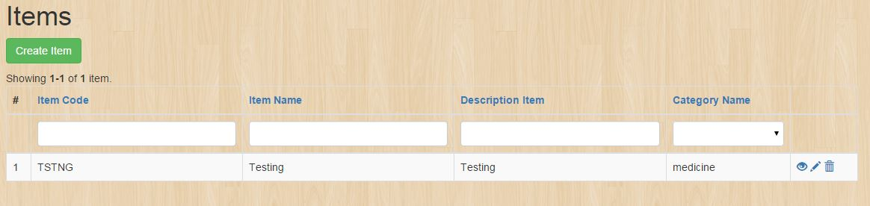

To create an item click this button:



Fill up this form to create an entity in the Item table:

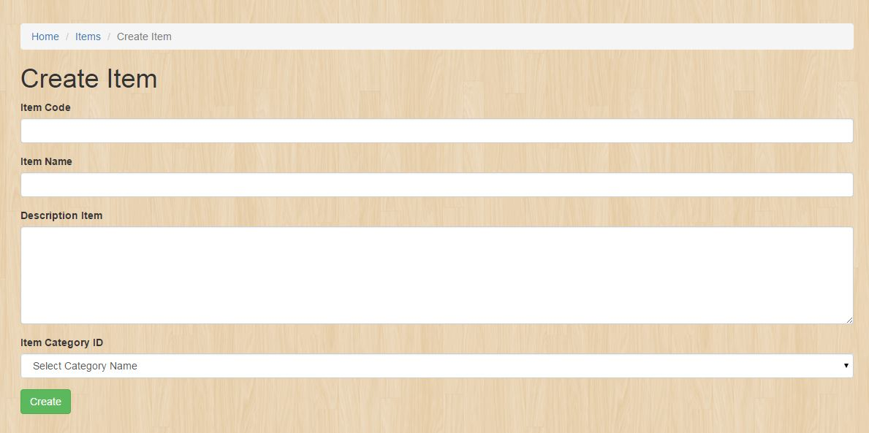

Item Description:

The picture below is to view the item description which is you can create, update and delete the item which you will create. It shows the reference table 1.1

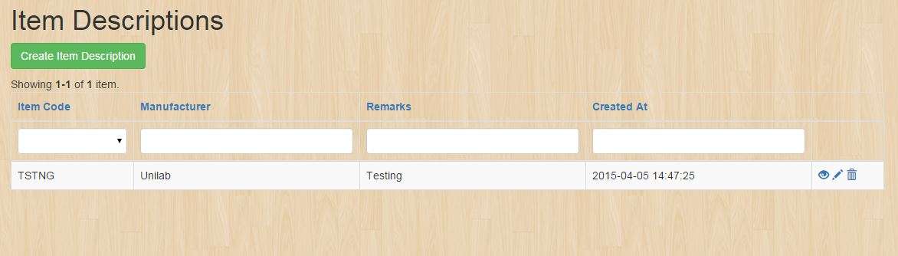

To create an item description click this button:



Fill up this form to create an entity in the item description:

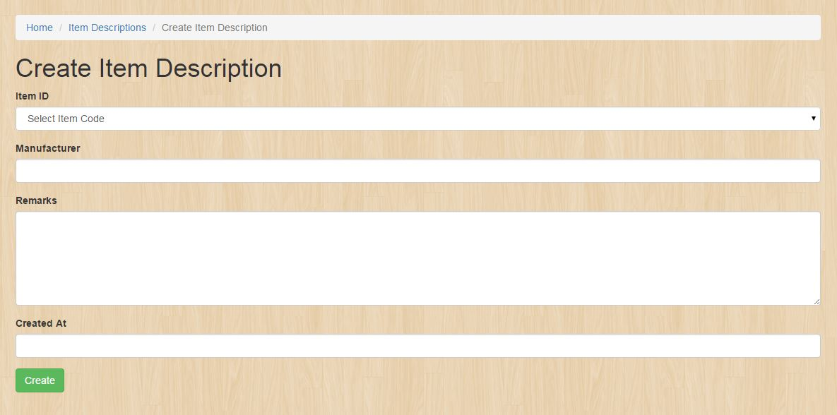

Location Table:

The picture below is to view the Location table which is you can create, update and delete the item you will create. It show the reference table 1.1

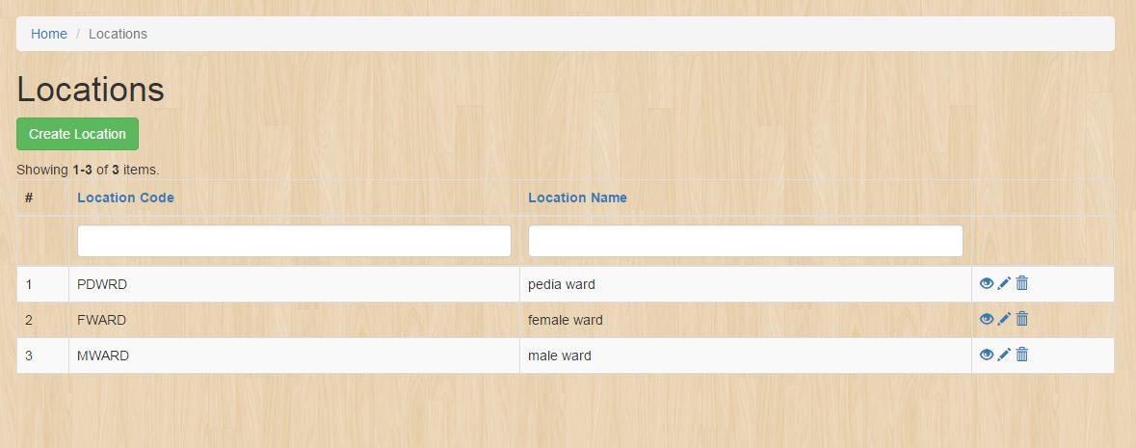

To create a Location just click this button:



Fill up this form to create an entity in the Location table:

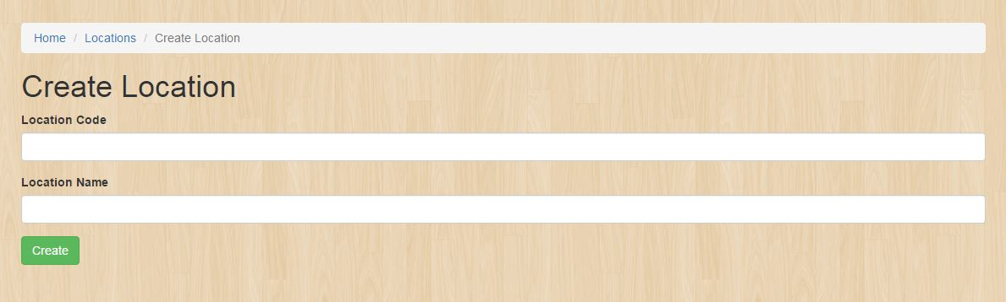

**Frontend Return Item Details:**

The picture below is to view the return item details which you can view the item you have been created. It shows the reference table 1.1

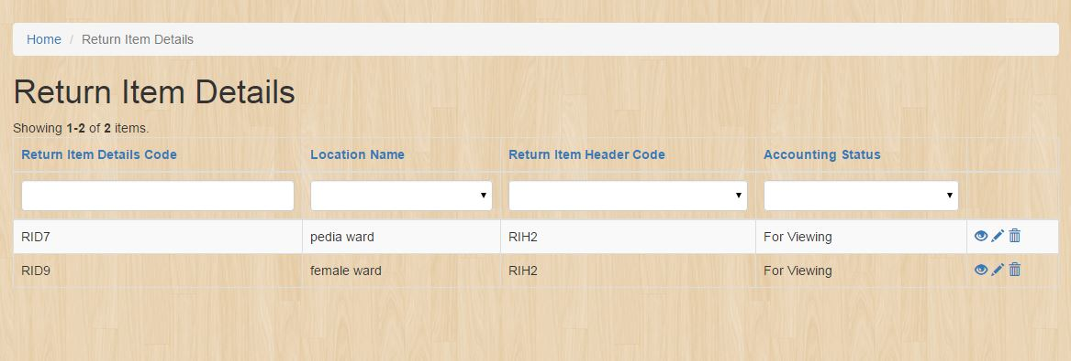

To view the return item details click this button:

